LAB 2 Report
Wenbo Geng
916207638

Part I: Basic Arithmetic and Logic Operations:
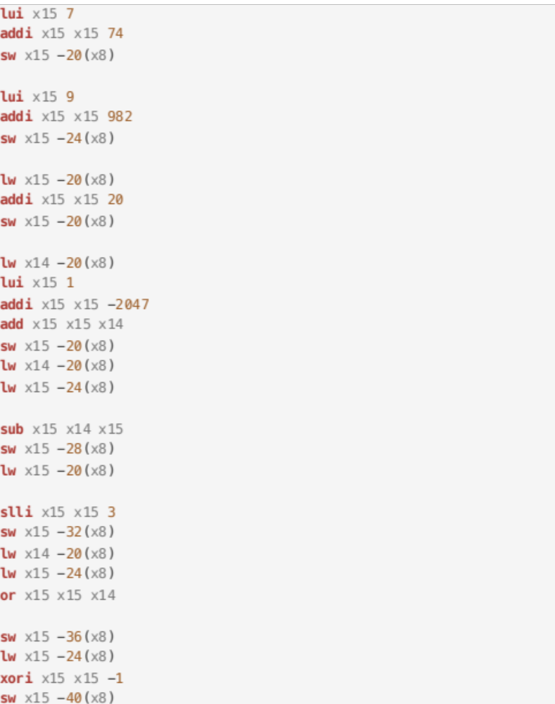
Code Block 1: Part 1 Code

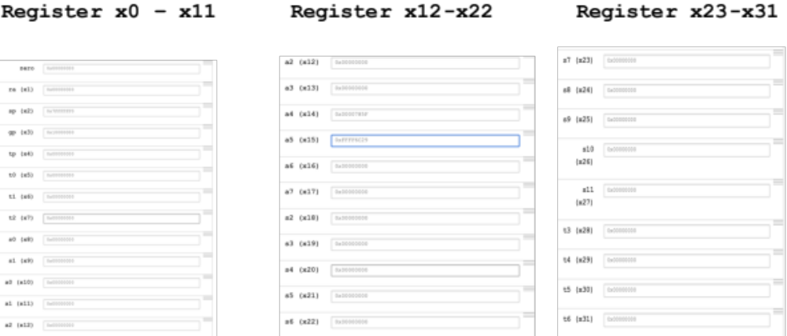

Part_1: Register Screen Capture

For the first calculation If there is no carry number in the process of adding two numbers a and 20. In the second calculation, there is a carry, just continue to repeat the above addition calculation until there is no carry number. For subtraction is same with addition. For multiplication we can be seen as multiple addition calculations or we can slice it and change the offset Since | is Bit logical OR. 1|1 or 1|0 is 1, 0|0 is 0 for ~ Bit logic inverse which stores binary complement which we can change the offset and take the reverse of the complement

Part II: Loading, storing, and initializing data:
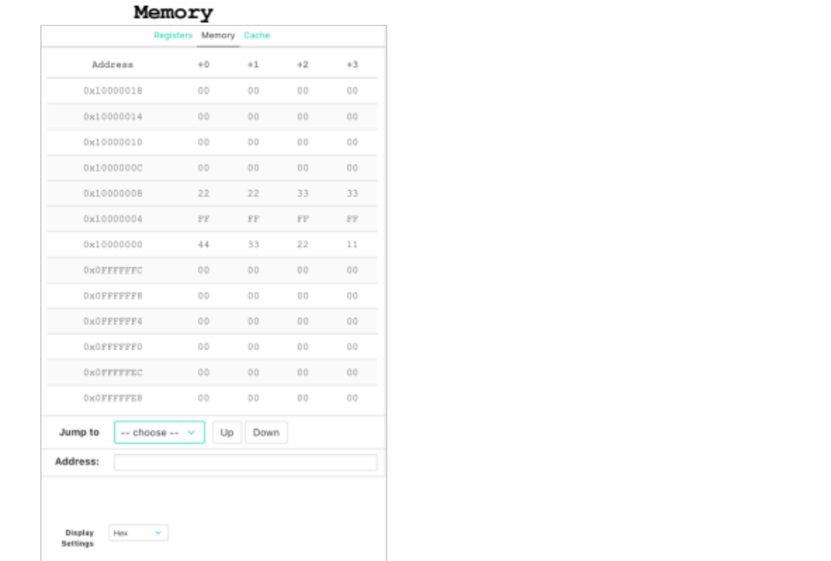
Part_2: Memory Screen Capture

Why: Because it’s static allocation for the elements in the address

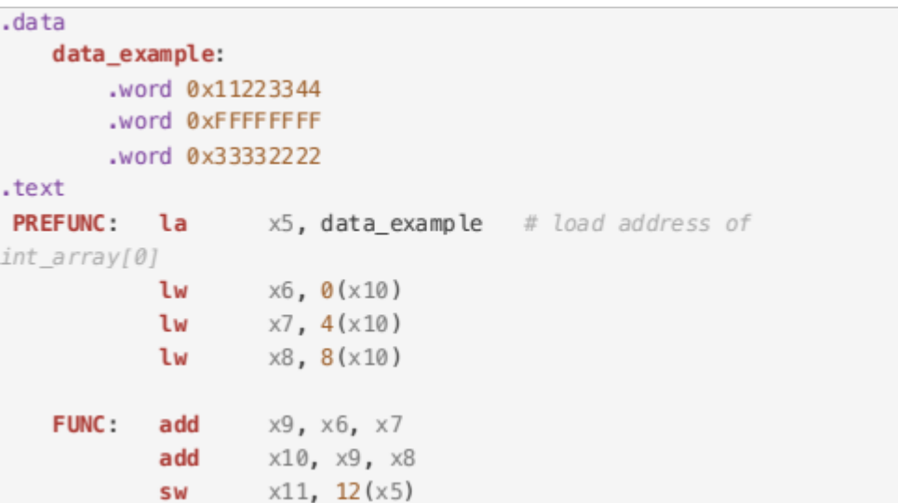
Code Block 2: Part 2 Code
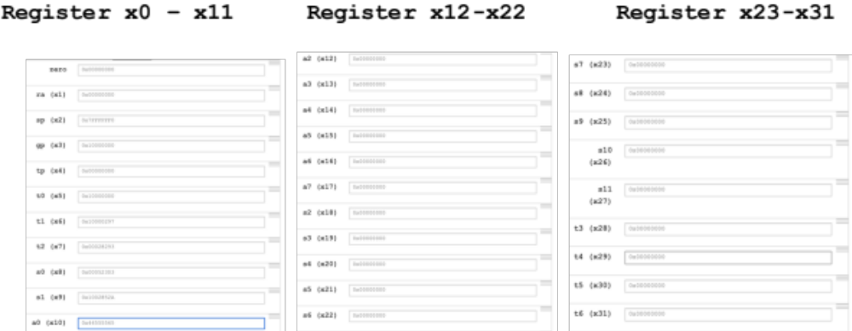
Part_2: Register Screen Capture
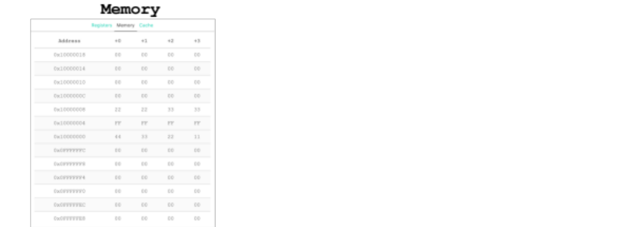
Part_2: Memory Screen Capture_2

Comparing the result on part 2c was stored as well as the complete register state as shown in Part I 4c. We used another memory to store the data we summed

Part III: Decision-making instructions:
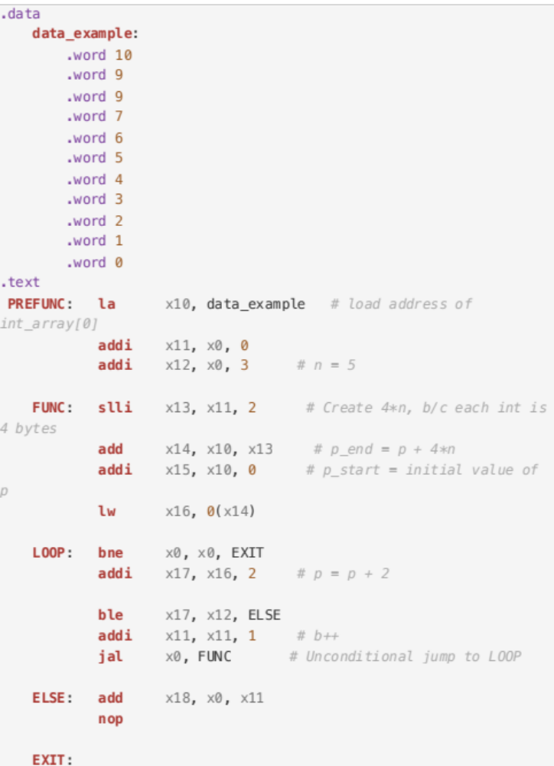
Code Block 3: Part 3 Code
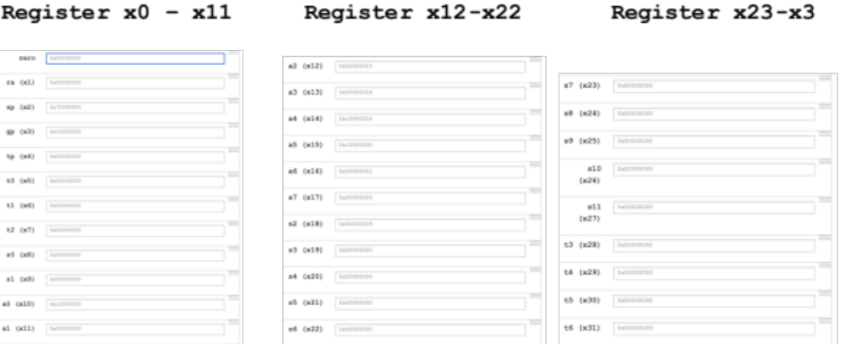
Part_3: Register Screen Capture
From our result it’s match to the code which it loops nine times and b from 0 keep adding 1 until 9 and c is equal to 9 as well storing in the different register

